Multi-Scale Character-Level CNN and Hybrid Feature Fusion for Lightweight Phishing URL Detection
Mid-term Progress Report

[TEAMMATE 1: add full name]
[Department / affiliation]
[City, Country]
[Email address or ORCID]
[TEAMMATE 2: add full name]
[Department / affiliation]
[City, Country]
[Email address or ORCID]
[TEAMMATE 3: add full name]
[Department / affiliation]
[City, Country]
[Email address or ORCID]

Abstract—
[complete with model results]: We prepared a reproducible data pipeline for phishing URL detection, including duplicate-aware cleaning, stratified train/validation/test splits, 23 handcrafted URL features, train-only feature scaling, EDA outputs, balanced and imbalanced evaluation sets, and a SMOTE-balanced training file for classical machine learning experiments.
Keywords— Phishing URL, CNN, Random Forest, hybrid models, deep feature fusion, lightweight models

Introduction
Phishing URL (Uniform Resource Locators) is a type of malicious attacks mimics legitimate websites to steal users credentials or deliver malware, millions of phishing sites are detected impacting millions of users and companies leading to billions of dollars loss every year as highlighted by a report from Interisle Consulting Group [1],This huge number of phishing URLs generated everyday makes it impossible to blacklist all of them in lookup tables as this will be computationally exhaustive and inefficient for real-time detection, Traditional approaches that depends on extracting lexical properties of URL string then using a classical models like Support Vector Machines SVMs or Random Forests has been used as an alternative however this approach suffer from limitations regarding the following
- The need for domain experience to engineer features which is time consuming and sometimes infeasible for huge variations of URLs generated every year
- The engineered features don’t generalize on features and since phishing URLs keep varying this models will fail to detect new phishing URLs patterns
- The semantic meaning of the feature is not used meaningfully to detect patterns. [2]
In more recent years Deep learning solutions have emerged as a strong alternative were various kinds of neural nets outperformed the classical baselines with their ability to auto learn features, on the top of them Convolutional Neural Networks which converts the URLs into learnable features of reasonable number of weights unlike the conventionally fully connected networks FCN, making CNN variations a lightweight deployable models, Our contribution is comparing Multi-scale Character level CNN as the main deep base line model to three other variations of CNN which are Bi-directional Long Short Term Memory BLSTM with CNN , fast-text embedding with CNN and a Hybrid feature fusion with CNN model that makes use of important features inclusion. Those models are rigorously compared across accuracy, F1-score, Precision and Recall,

Related work

Classical Feature-Based Approaches
[expand with literature]: The data pipeline supports the classical feature-based direction by extracting lightweight lexical and structural URL features such as URL length, hostname length, path/query length, special-character counts, digit ratio, HTTPS usage, IP-address usage, subdomain depth, path depth, hostname hyphen usage, entropy, and suspicious keyword count. These features are intended for the traditional ML baselines and for comparison with the character-level deep models.

Character-Level Deep Learning
The most recent literatures in the field offers a variety of approaches for using CNN in phishing URLs detection which establish the foundation for our approach, as follow

URLNet: Learning a URL Representation with Deep Learning for Malicious URL Detection starting with by Le et all (2017) which compares character-level CNN , word-level CNN and a hybrid character + word including special characters and character level word embedding which achieved higher AUC than both the standalone character -level CNN (0.9828)and word-level CNN (0.973) at of 0.9885 however this is not significantly higher than the character-level CNN which doesn’t justify the overhead of developing a hybrid model of both. [2], this motivates using character-level CNN as a straight forward approach with strong performance.

PhishGuard: A Convolutional Neural NetworkBased Model for Detecting Phishing URLs with Explainability Analysis [3]: This paper presents a model for detecting phishing URLs based on a 1D convolutional neural network (CNN) with explainability analysis. achieving 99.85% accuracy.the analysis showed that URL length and domain name length are the most important which motivates our hybrid deep feature fusion method.

A Deep Learning-Based Phishing Detection using CNN , LSTM and a hbrid LSTM-CNN [4], The study uses a dataset comprising both phishing and legitimate URLs, with features automatically extracted. Experimental results show accuracies of 99.2% (CNN), 97.6% (LSTM-CNN), and 96.8% (LSTM). The CNN model proves superior to other methods in detecting phishing URLs confirming our approach.

Enhanced Phishing URL Detection Using Convolutional Neural Networks: A Deep Learning Approach [5], proposes a CNN with word2vec solution to leverage the semantic understanding, however since phishing URLs typically involve misspilled words a subword embedding mechanism is prefered which motivates experimenting with fastext + word level CNN which is considered a subword n-gram embedding offers a lightweight approach suitable for our CPU only constrain.

PhishDetect: A BiLSTM based phishing URL detection framework using FastText embeddings reaching 99.17% accuracy, which enforce our fast-text+ CNN model approach.[6]

Handling Class Imbalance
[add model-side handling] From the data preparation side, we handled imbalance without changing validation or test distributions. We used stratified splitting to preserve the original class ratio, created a balanced 50/50 test set and an imbalanced 80/20 legitimate/phishing test set for evaluation, and prepared one SMOTE-balanced scaled training file for optional classical ML experiments. SMOTE was applied only to the training feature set, not to validation, test, or raw URL strings.

Dataset

Dataset Source and Initial Audit
We used a phishing URL dataset with two columns: URL and Label. The URL column contains the raw URL string, and the Label column indicates whether the URL is legitimate or phishing. The label mapping is 0 for legitimate URLs and 1 for phishing URLs. We selected this dataset because it supports both directions of the project: raw URL strings for the character-level CNN/RNN model and handcrafted numerical features for the classical machine learning baseline.
The raw dataset contained 149,726 rows and 2 columns. Before cleaning, we checked the dataset shape, column names, data types, missing values, empty URL strings, binary label values, initial class distribution, duplicate URLs, and conflicting labels. These checks confirmed that the labels were binary and that the data was suitable for the next processing steps.

Cleaning and Leakage Prevention
We stripped whitespace from URL strings before checking duplicates. This avoids treating the same URL with an extra space as a different URL. We then checked for duplicate URLs and checked whether any repeated URL had conflicting labels. No conflicting labels were found. Duplicate URLs were removed before splitting to reduce data leakage risk between the training and test sets. After cleaning, the dataset contained 129,776 rows: 74,972 legitimate URLs and 54,804 phishing URLs.
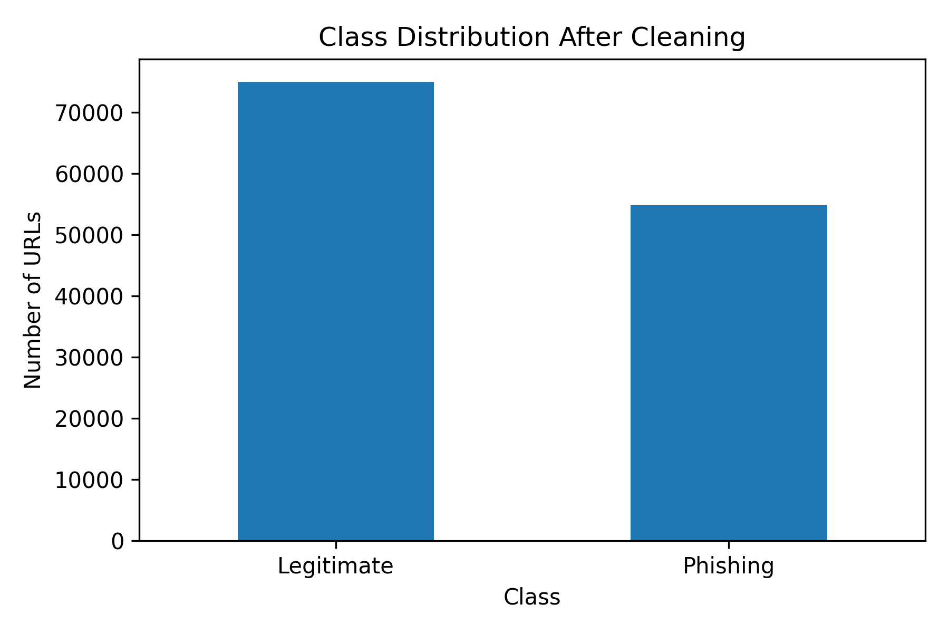
Figure D1: Class distribution after cleaning.

Train, Validation, and Test Split
After cleaning, we created a stratified 70/15/15 split. Stratification was used because the dataset is mildly imbalanced, and we wanted the class ratio to remain consistent across the training, validation, and test sets. The final split sizes were 90,843 rows for training, 19,466 rows for validation, and 19,467 rows for testing. The validation and test sizes differ by one row because the cleaned dataset size does not divide perfectly into the selected split ratio.

Preprocessing pipeline

Handcrafted URL Feature Extraction
For the classical machine learning baseline, we extracted 23 handcrafted URL features from each raw URL. These features describe the structure and composition of the URL without loading webpage content. The extracted features include length-based features such as url_length, hostname_length, path_length, and query_length; character-count features such as num_dots, num_hyphens, num_digits, and num_slashes; ratio and complexity features such as digit_ratio and shannon_entropy; URL structure features such as has_https, has_ip_address, subdomain_depth, path_depth, and hostname_has_hyphen; and a suspicious_keyword_count feature.
During development, we refined the URL parsing step by using parsed.hostname instead of parsed.netloc. This made the hostname-based features cleaner because netloc can include port numbers, while hostname returns the actual host. The final feature files contain 23 features plus the Label column. Their shapes are 90,843 x 24 for training, 19,466 x 24 for validation, and 19,467 x 24 for testing.

Feature Scaling
We created scaled versions of the handcrafted feature files using StandardScaler. This was needed for scale-sensitive models such as Logistic Regression and SVM. To avoid data leakage, the scaler was fitted only on the training features and then applied to the validation and test features. The fitted scaler was saved as models/standard_scaler.joblib. We also kept the unscaled feature files because tree-based models can use them directly.

Exploratory Data Analysis
We generated EDA tables and figures to understand how legitimate and phishing URLs differ. The full URL length plot showed very large outliers, so we also generated a capped version at the 99th percentile for readability. We did not remove the outliers from the actual dataset because long URLs may carry useful phishing signals.
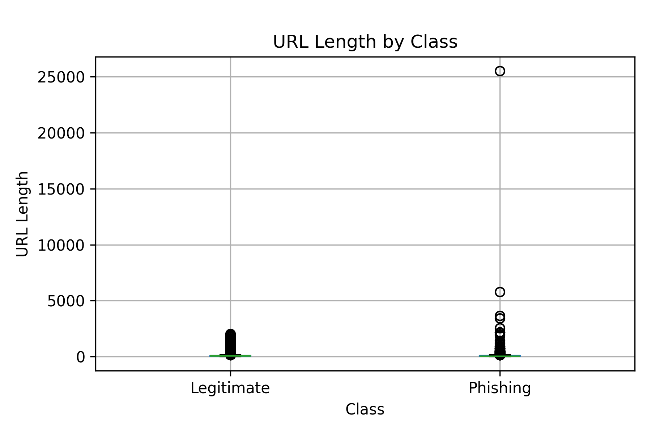
Figure P1: URL length by class, including outliers.
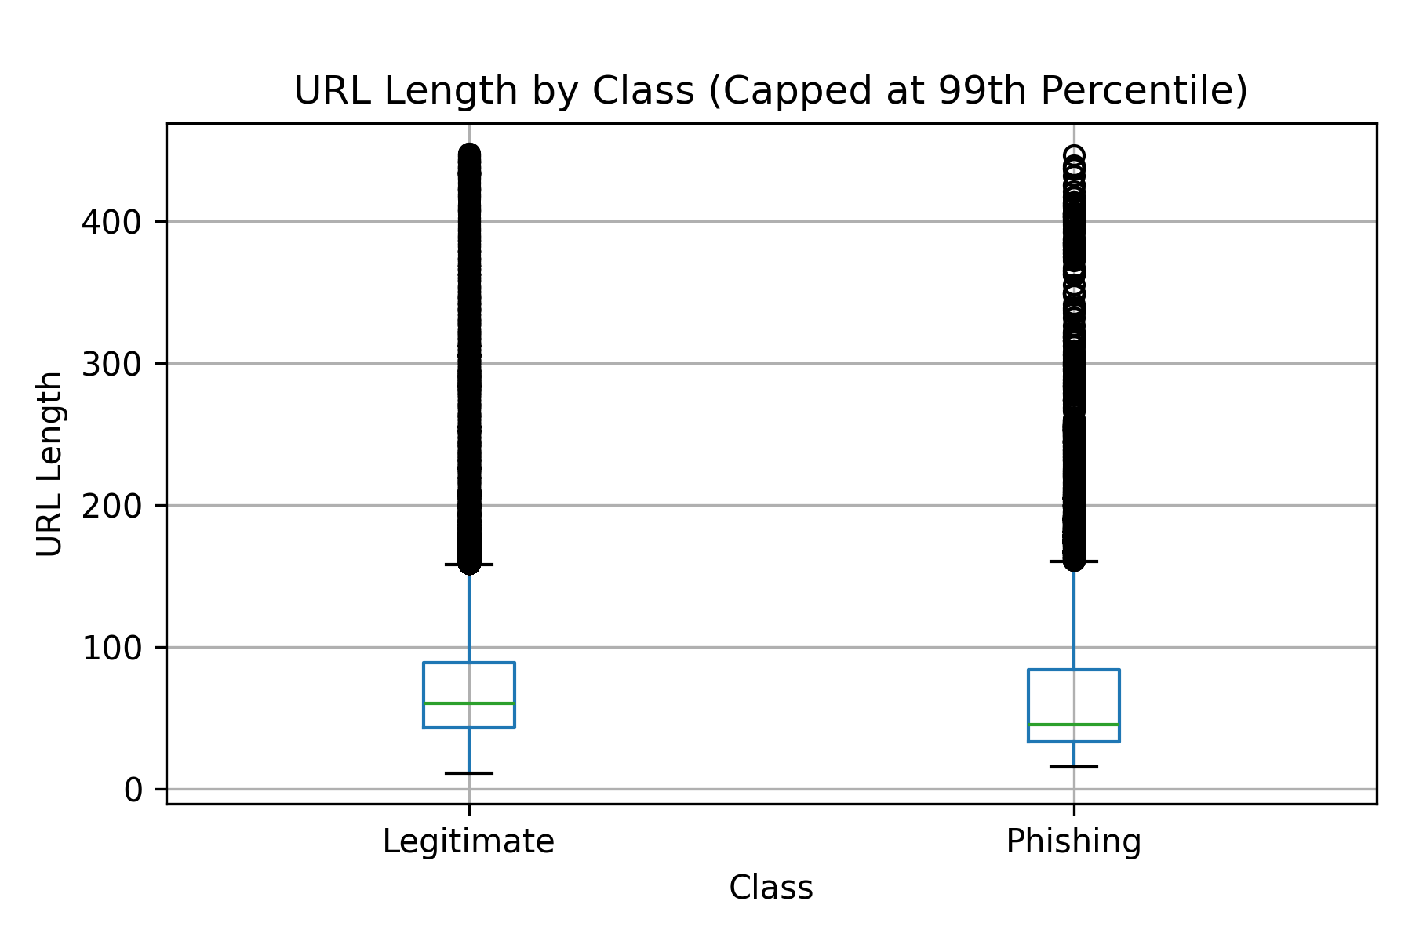
Figure P2: URL length by class capped at the 99th percentile for readability.
We also compared Shannon entropy and digit ratio. These features did not fully separate the two classes on their own, but they can still contribute useful information when combined with other URL signals.
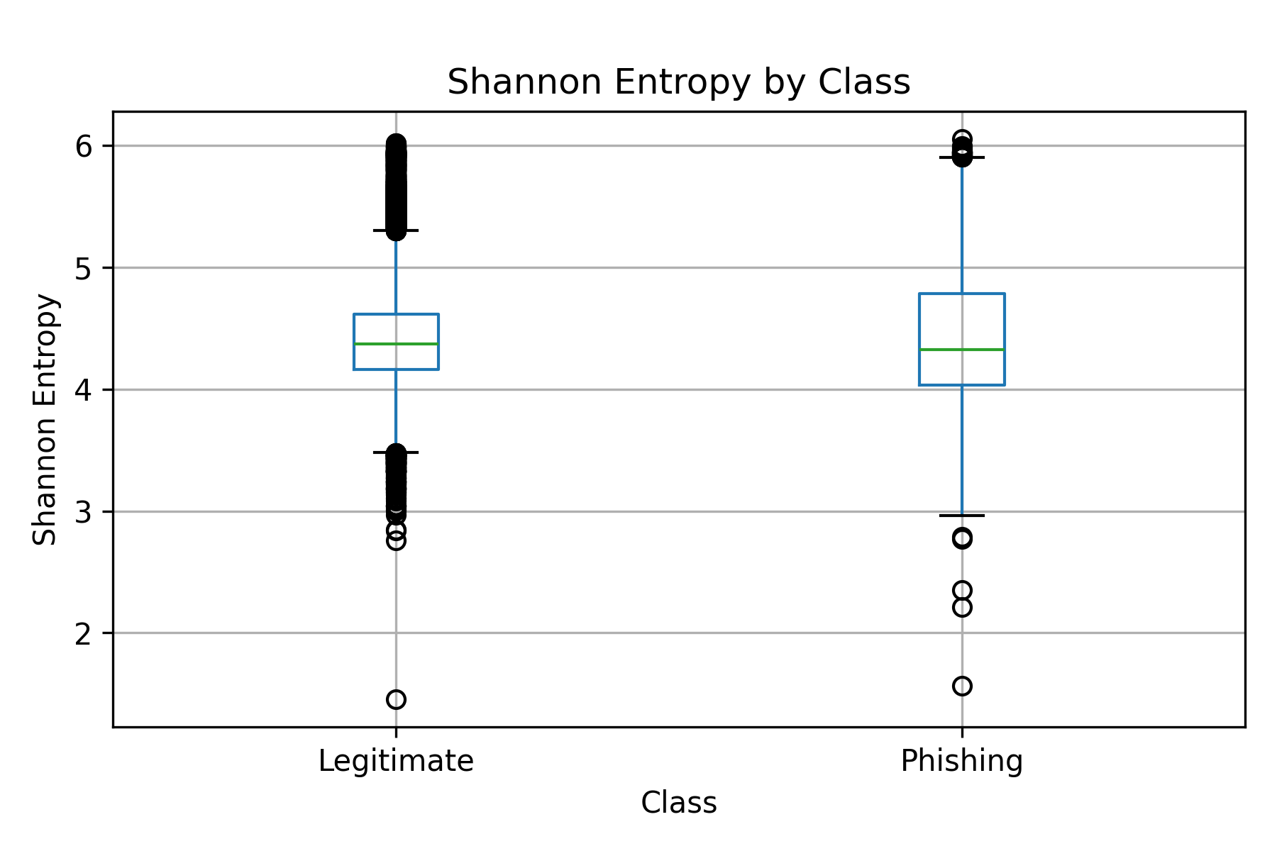
Figure P3: Shannon entropy distribution by class.
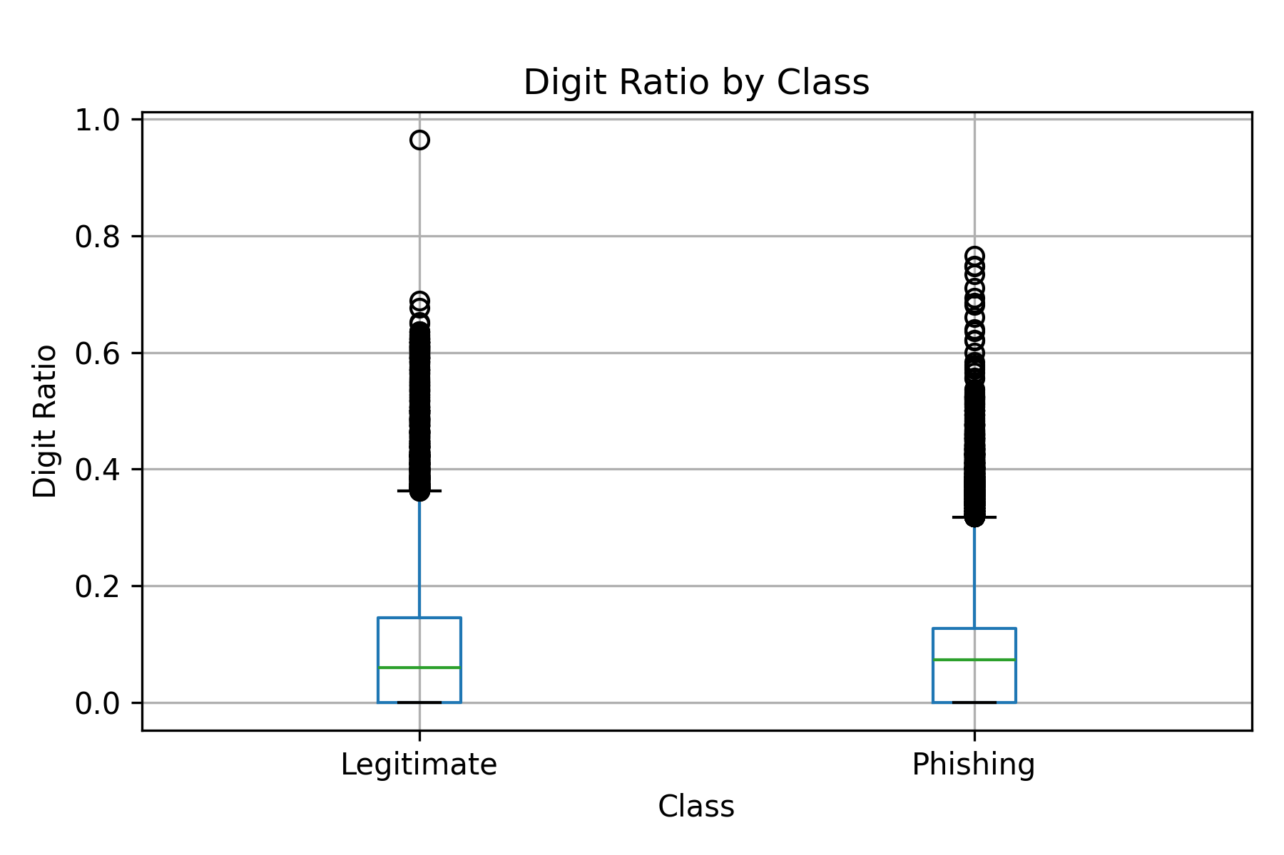
Figure P4: Digit ratio distribution by class.
The binary feature rate analysis showed that HTTPS appears in both legitimate and phishing URLs, so HTTPS alone is not enough to classify a URL as safe. However, hostname_has_hyphen appeared much more often in phishing URLs, making it a useful signal for the classical baseline and for the later hybrid feature-fusion model.
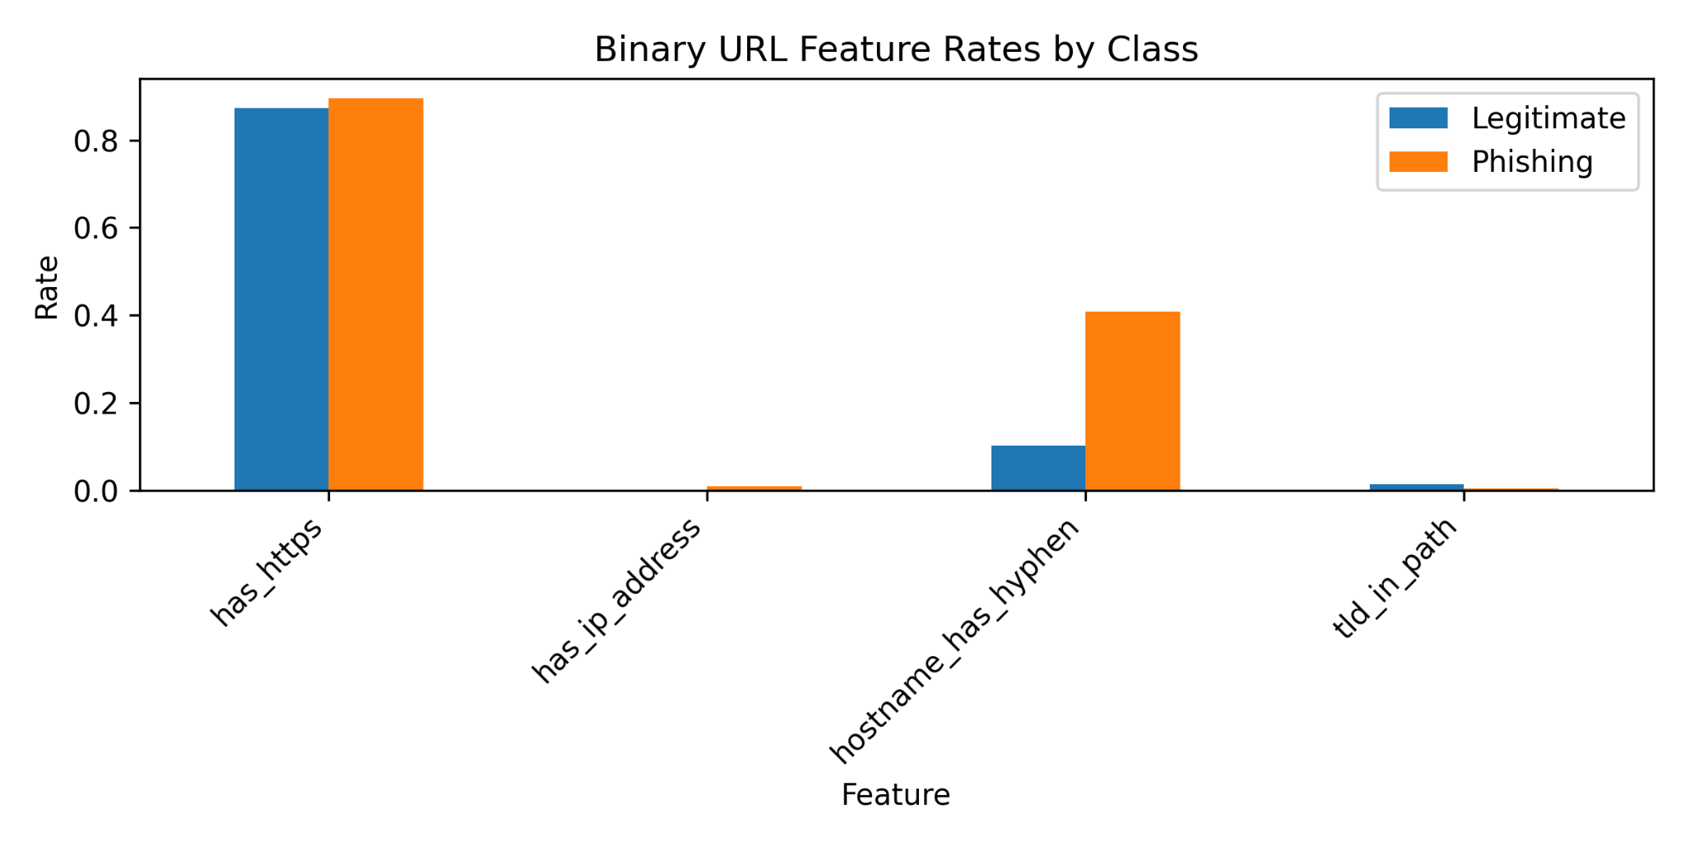
Figure P5: Binary URL feature rates by class.
We also reviewed top-level domains. Both classes used common TLDs such as .com, but phishing URLs showed frequent use of TLDs such as .dev, .app, .network, .top, and .link. This does not mean these TLDs are always suspicious, but it provides useful context for the dataset.
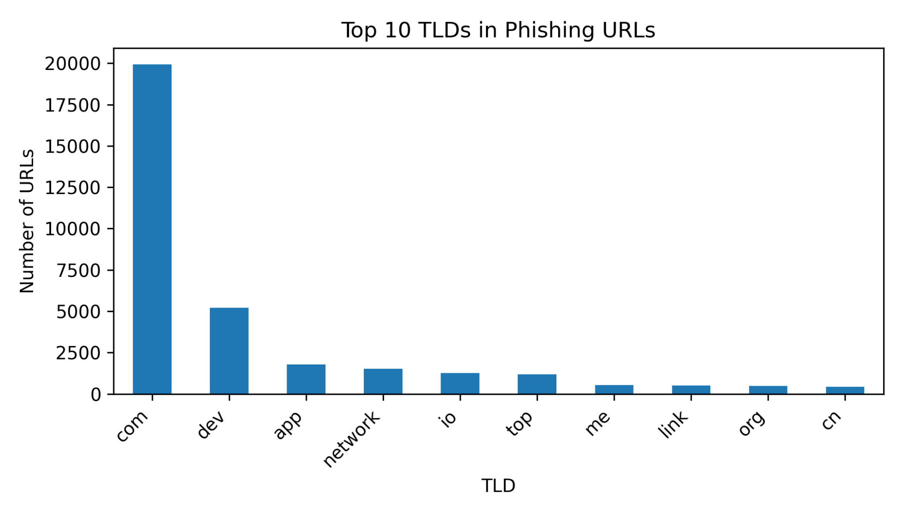
Figure P6: Top 10 TLDs in phishing URLs.
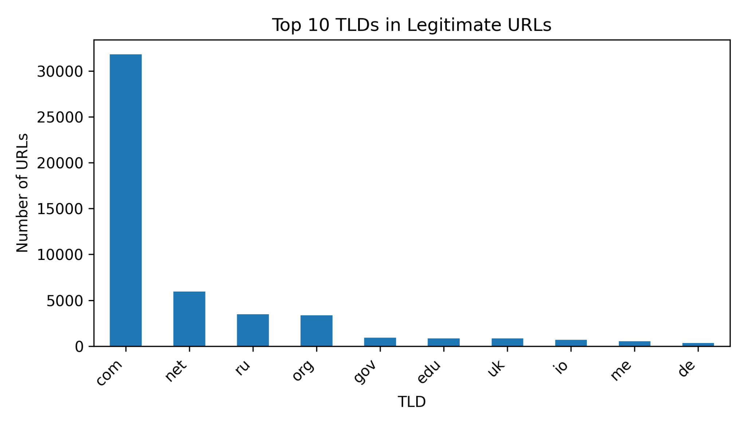
Figure P7: Top 10 TLDs in legitimate URLs.
Finally, we created a correlation heatmap for selected numeric features. The heatmap shows that no single handcrafted feature fully explains the label. This supports using a model that combines multiple URL signals instead of relying on one rule.
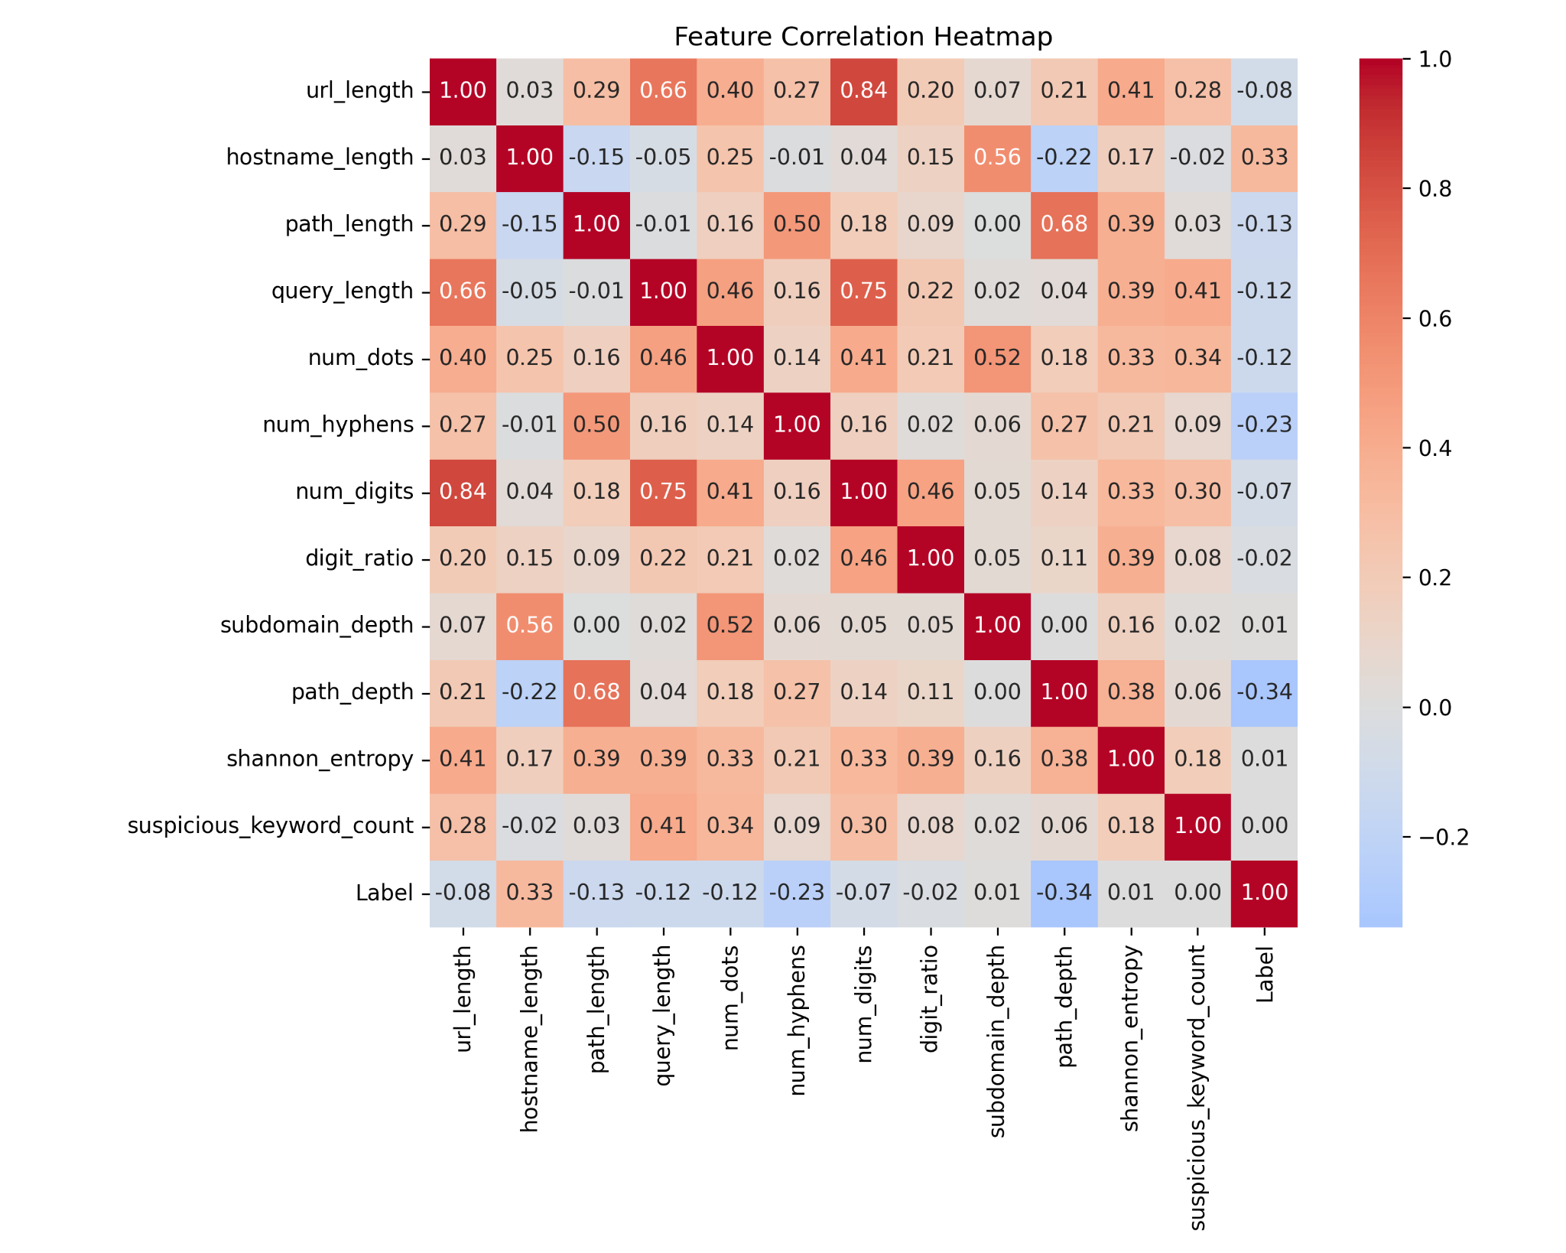
Figure P8: Correlation heatmap for selected handcrafted features.

Balanced and Imbalanced Evaluation Sets
We created two additional test sets for later model evaluation. The balanced test set contains 16,442 rows with 8,221 legitimate URLs and 8,221 phishing URLs. The imbalanced test set contains 14,057 rows with 11,246 legitimate URLs and 2,811 phishing URLs, which gives an 80/20 legitimate-to-phishing ratio. These files are intended for evaluation only, not training.

SMOTE Training File for Classical ML
We created one SMOTE-balanced training file for optional classical machine learning experiments. SMOTE was applied only to the scaled training features and was not applied to validation or test data. Before SMOTE, the training set had 52,480 legitimate samples and 38,363 phishing samples. After SMOTE, both classes had 52,480 samples.
We did not create an unscaled SMOTE file. SMOTE is distance-based, so applying it after scaling is more appropriate. It also creates synthetic numerical feature vectors, not real URL strings, so the SMOTE file should not be used for the character-level CNN/RNN model.

Final Pipeline Outputs
At the end of the notebook, we added final validation checks to confirm that the saved clean dataset, split files, unscaled feature files, and scaled feature files match the current notebook outputs. The generated files summary documents 34 output files, including the cleaned dataset, splits, feature tables, scaled feature tables, evaluation sets, EDA figures, EDA tables, the SMOTE file, and the saved scaler.

Traditional models
[C to add model results]: The traditional model section can use three versions of the prepared data: unscaled handcrafted features for tree-based models such as Decision Tree, Random Forest, XGBoost, or LightGBM; scaled features for scale-sensitive models such as Logistic Regression or SVM; and the optional SMOTE-balanced scaled training file for imbalance experiments. The balanced and imbalanced test feature files are also ready for evaluation.

Deep Models Implementation

Design Rationale
Our main deep-learning approach Char-CNN with multiscale kernel treats each URL as a raw character sequence, unlike word or token level models, a character level representation is a simple straight forward approach that requires no vocabulary normalization, which produces a compact fixed-sized vocabulary of the ASCII printable set. However, Previous literature advocates for the superiority of Char-CNN, we will train three other variations of more sophisticated architectures, our hypothesis is that hybrid fusion will outperform multi-scale CNN and thus four models are trained and compared based on accuracy, F1-score, precision, recall and also efficiency score (F1/number of parameters) to represents the tradeoff of model performance against model weight and training overhead, the four models are as follow:
- Char-CNN with multi-scale kernels
- Hybrid CNN+ Bi-LSTM
- Fast-Text + CNN (sub-word n-gram embeddings)
- Hybrid Feature Fusion (deep features + hand-crafted statistical features).

Character Vocabulary
A Char-Vocab class is built by counting all characters appearing in training corpus, characters with fewer than 3 times occurrence frequency is treated as unknown (<UNK>), and vocab was set to be capped at 100 entries however the resulting vocab size was 92 as expected and no capping was needed, all the URLs are normalized to a maximum length of 200 tokens, this threshold was selected by visualizing the distribution of URLs length , which showed that the URL lengths are heavily right skewed, using box plot shows that the upper bound ( Q3 + 1.5*IQR) of URLs lengths is roughly at 200, as shown below.
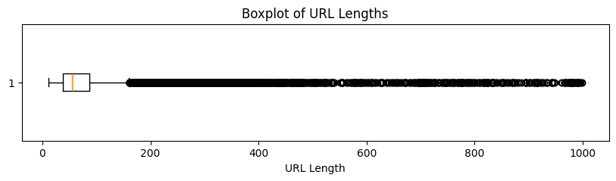
Figure 1 : URL BOX plot highlighting outliers and the upper bound whisker roughly selected as the maximum length threshold of 200.

upper bound was selected as threshold to avoid excess truncation of characters, however deeper analysis of extremely long (above 1000) URLs reveled that the majority of them are phishing URLs, which enforces the hypothesis that hybrid fusion model with URL length and other crafted features would be useful in phishing URL recall.
Two special tokens are included:
- <PAD> (index 0): appended to short URLs to reach
- <UNK> (index 1): replaces unseen characters at inference time.

PyTorch Dataset and Data Loading
The URL Dataset class was used to wrap the dataset, Each sample is encoded by the vocabulary dictionary, and padded or truncated to fit the maximum length of 200 characters, and returned as a pair with the label ( 0: benign or 1: phishing) , Data augmentation was used to stabilize model and prevent overfitting , where random token masking to <UNK> is applied at training time with probability of 10% for a URL to be selected for augmentation, within a selected URL, each token that is not padding or unknown token is replaced with <UNK>, which improve generalization with model learn to adapt to new or unseen data, class imbalance is mitigated with weighted sampling, where each sample is assigned a weight inversely proportional to its class frequency, then the model is evaluated against the validation and test samples without balancing to mimic realistic inference case, a mini-batch of size 256 is used leading to 355 batch per epoch as the training dataset is of size above 90 ,000 with considering <PAD> tokens added to short URLs.

Char-CNN Architecture
The primary implemented model is a multi-scale character level CNN whose architecture is shown in the figure below.
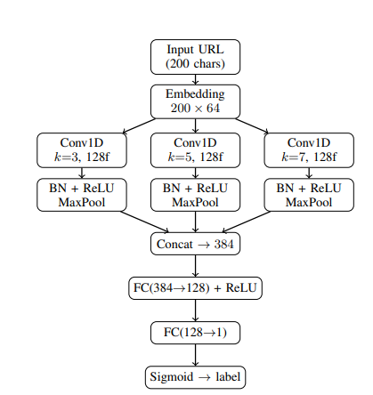Figure 2 : Multi-scale Char-CNN architecture, with three parallel convolution kernels of sizes 3, 5, 7 capturing short, medium and longer character n-grams respectively.

Input URL : each character is represented by a single number according to vocablary dictionary of 92 entries + two special tokens a <PAD> token of 0 and a <UNK> token of 1as highlighted in Data Loading section above.

Embedding Layer: Each character is represented by a dense vector of length 64, thus each URL is represented by a matrix of size 200 token x 64 embedding .

Multi-Scale convoution: following URLNet by Le et al [2] multiscale approach but limiting the parallel kernels to only 3 with kernel sizes { 3, 5, 7} to capture short n-grams like (eg. net, www ,..etc), medium ones and long ones like (eg. paypal, secure,..etc) and 128 filters each scan the sequeunce of character embeddings,each branch is followed by batch normalization to avoid exploding gradients and Rectified Linear Unit RelU activation.

Global Max pooling: a single global max-pool over sequence dimension reduces each branch’s output from [256,128,200] to [256,128], keeping only the strongest signal of activation regardless of position. Reducing the dimensionality and the parameters training needed significanlty.

Feature Concatenation and Classification Head: The three 128-dimensional branches into 384 features and then dropout layer with (p=0.3), a fully connected network from 384 to 128 with ReLU activation ,followed by another dropout layer and finally fully connected layer from 128 to 1 which produces probability score of being phishing, predicted labeld will be calculated by using sigmoid fucntion.

The Total number of trainable parameters is roughly 179,329 is considered to be lightwieght and CPU compatiable.

Training configuration

Loss Function: Binary Cross Entropy with Logits is used with a postive class weight to further penalize false negatives

Optimiser and Scheduler: Adam optimiser with learining rate η= 10**-3 and wieght decay λ = 10 **-4 is used, Gradient clipping at 1 prevents exploding gradients.

Early Stopping terminates if the validation loss failed to improve by at least δ = 0.001 for 5 consecutive epochs, preventing overfitting, however earlystopping conditions were not met during Char-CNN models.

Random seed for numpy.random.seed(42) and torch.manual_seed(42) is used for all experiments to preserve consistency across runs.

Planned Architectures (for Final Report)

CNN + BiLSTM: A bidirectional LSTM layer will be implemnter after the convolution feature extraction to capture long sequential dependencies, where the CNN capture local n-grams features while the BiLSTM captures global context.

FastText + CNN: subword n-gram embeddings pretrained with FastText provinding out-of-vocab combinations handling.

Hybrid feature Fusion: A fusion modl that combine the deep character-level features of char-CNN with a hand crafted statistical feature vector motivated by EDA and feature importances analysis of the traditional random forest model.

Preliminary Results

Char-CNN
The model is trained for 15 epochs starting with training accuracy 91.57% and validation accuracy of 97% this is expected due to the data augmentation and dropout applied which makes the training initially challenging, however the model shows stable increase in accuracy for both training and validation
Model | Accuracy | Precision | Recall | F1-score | Params(M)
Char-CNN | 99.12% | 98.6% | 99.3% | 98.96% | 0.179329

Project Timeline
week | Millstone
1 | Dataset collection and preprocessing (Ahmed) / Related work literature review (Zainb & Fatma)
2 | Char-CNN implementation (Zainb)/ Baseline models (Fatma)/Mid-term Report (All)
3 | CNN + Bi-LSTM / Fast-text +CNN
4 | Hybrid fusion model + Final Report

Conclusion
[complete with modeling results]: The data preparation stage is complete and provides a clean, reproducible foundation for both raw URL deep learning and feature-based classical ML experiments. The pipeline includes leakage-aware cleaning, stratified splits, handcrafted features, safe scaling, EDA outputs, balanced/imbalanced evaluation sets, and a training-only SMOTE feature file.

References
- G. Interisle Consulting Group, LLC, “Phishing Landscape 2023: An Annual Study of the Scope and Distribution of Phishing,” 2023. [Online].Available:https://interisle.net/insights/phishinglandscape2023. [Accessed: 20-Mar-2024].
- Le et al., “URLNet: Learning a URL Representation with Deep Learning for Malicious URLDetection,” NDSS 2018.https://arxiv.org/abs/1802.03162
- M. R. Islam, M. M. Islam, M. S. Afrin, A. Antara, N. Tabassum, and A. Amin, ”PhishGuard: A Convolutional Neural Network Based Model for Detecting Phishing URLs with Explainability Analysis,” arXiv preprint arXiv:2404.17960, 2024.
- Z. Alshingiti, R. Alaqel, J. Al-Muhtadi, Q. Haq, K. Saleem, and M. Faheem, ”A Deep Learning-Based Phishing Detection System Using CNN, LSTM, and LSTM-CNN,” Electronics, vol. 12, p. 232, Jan. 2023. doi: 10.3390/electronics12010232.
- A. Kumar, S. Sharma, and R. Patel, “Phishing URL Detection Using Deep Learning with CNN Models,” in Proc. IEEE Int. Conf. on Advanced Computing and Communication Systems (ICACCS), 2025, pp. 1–6, doi: 10.1109/ICACCSXXXXX.
- J. Smith and A. Lee, "PhishDetect: A BiLSTM based phishing URL detection system," 2022.

